a practical guide tO ROWING AND TRAINING For Adults
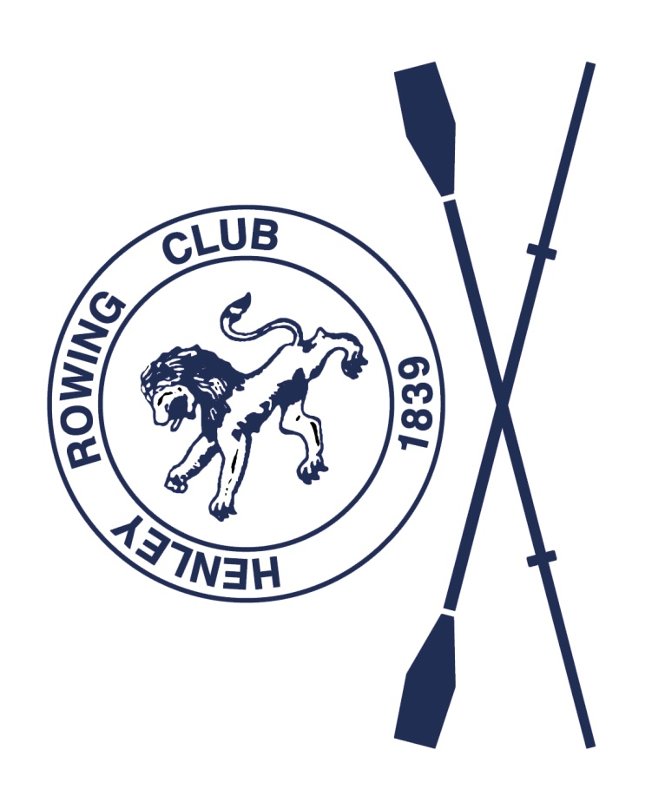

Contents
Introduction 4
Background: How is Henley Rowing Club organised? 4
Rowing Terminology 5
Glossary of rowing terms 7
Communication Methods 8
Membership of British rowing 9
Club Policies 9
Medical, Health and Safety 9
Health and hygiene 9
Medication and drugs 10
Diet and hydration 10
Sun Exposure 11
Hypothermia 11
Blisters 12
Weill's Disease – Leptospirosis and Bird Flu 12
First aid equipment and defibrilator 12
Pontoons (rafts) 12
What to wear: Rowing kit 13
Competition kit 13
Training kit 13
Events – Regattas and Head Races 14
Dates 14
Help at Events 14
Costs - Competition, Travel and Accommodation 14
Useful Location Information 15
Photographs 16
Boats and equipment 16
Boat House and care of equipment 16
Risk assessment and Rules of the river 17
Appendix 1: Navigation plan for the Henley Reach 18

Introduction
This guide to rowing and training for adults at Henley Rowing Club has been produced following our successful ‘Practical Guide to Rowing and Training for Juniors and their Parents/Carers’ booklet first introduced in 2010 It was recognised that many adult members of the club, particularly those new to rowing on our Learn to Row courses, could benefit from having a source of practical information and helpful hints and tips to make their rowing experience enjoyable and as safe as possible. Whether you are an experienced rower, or new the sport or the club, we hope you find this booklet helpful.

Background: How is Henley Rowing Club organised?
Henley Rowing Club was founded in 1839 and is one of the oldest rowing clubs in Great Britain. In 2018 members voted for a change to become a Charitable Incorporated Organisation (1178400). The operations and management of the club are run on an entirely voluntary basis. The managing committee consists of the officers of the club (Chair, Treasurer and Secretary), who are all trustees, and the Captain (who is not a trustee) together with up to six other trustees and roles which are co-opted to the committee (currently these are Welfare and Henley Open Events).
The Henley Open Events committee is responsible for running the two club events, Henley Sculls in November and Henley 4s and 8s in February, each year. These provide valuable funds for the club. The club relies on members to volunteer to run both these events. Additionally during Henley Royal Regatta the club raises funds by managing camping, car parking and mooring at the club with the help of volunteer club members. Volunteers also run the club catering on weekend mornings, when members are able to purchase hot food and drinks after the training sessions.
The club is affiliated to the national governing body, which is British Rowing. More information is provided in the ‘Membership’ section.
At Henley Rowing Club we provide rowing for everybody to meet aspirations ranging from social rowing to top level competition and have set up our squad system to deliver this. The biggest squad at the club is the Junior squad, for young people aged between 13 -18), with each squad having at least one coach. Adults are split between ‘Seniors’ and ‘Masters’. Our current senior squad consists of young experienced rowers who train six times a week and are aiming for national level competition. From age 27 years Seniors can row as ‘Masters’, which is an age-related handicap system in line with international rules of racing. The Club has a growing Masters section of men and women who have a dedicated coach and training programme. Masters racing is great fun and highly competitive. There are local, national and international events for masters rowers which can be found on several websites listed later in this document.
Our aim for Learn to Row course graduates is to enable them to gain competence to gradually integrate with the Seniors or Masters squads so that they can gain experience and confidence in crew boats with the aim of competing if they wish. There are increasing opportunities for those new to the sport (termed ‘novices’) to race competitively and the club attends various events to give opportunities to race. Additionally, the British Rowing Masters Championships (June), the Vesta Veterans Head (March), the Henley Masters Regatta (July), and the Veteran Fours Head (November) are all hotly contested events. Internationally, Masters rowers have an annual championships called the World Rowing Masters Regatta.
Members also enjoy the river on a recreational basis. There are many club members who row for recreational reasons and are independent of the squads by choice (often they own their own boats). The club also has boats that can be booked for use on a self-serve basis.

Rowing Terminology
For those new to the sport, there is a lot of information on the British Rowing web site:
https://www.britishrowing.org/go-rowing/types-of-rowing/sliding-seat-rowing/
As with many sports, there can be a lot of terminology to get to know. Here is a guide to some of the rowing vocabulary you will come across:
Types of boats
The types of rowing boat are broadly split into two categories; ‘sculling’ where each rower has two blades (oars), one in each hand and ‘sweep’ rowing where each rower has one blade (oar).
In sweep rowing the blade is either on the rower’s left side also known as bow side (starboard) or on the rower’s right side also known as stroke side (port). A boat has equal numbers of bow and stroke side blades.
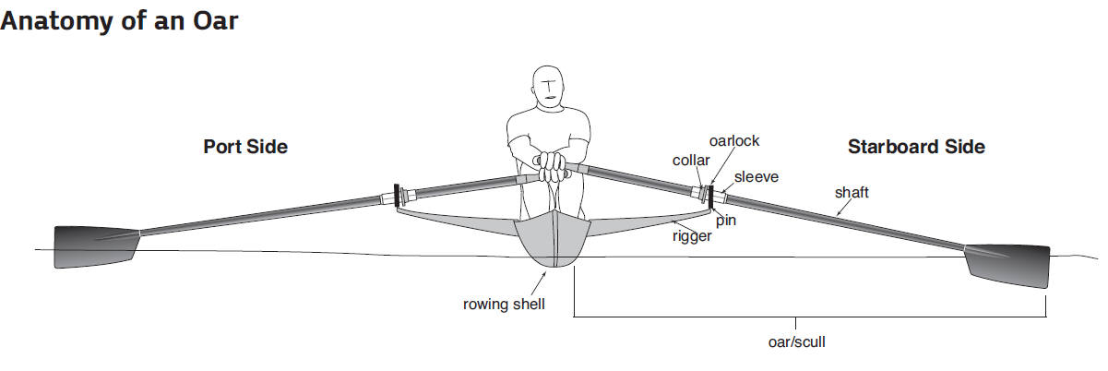
Bow side (Left)
Stroke side (right)
spoon
The boats (shells) generally have one, two, four or eight seats and are classified according to the number of people and whether they are sweeping or sculling.

Pictorial | Name | Symbol | Description
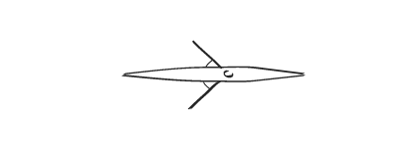 | Single scull | 1x | One rower, with 2 blades. The rower steers the boat by changing the pressure they put on each blade in the water.
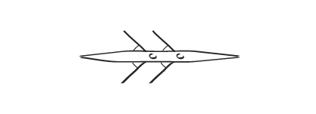 | Double scull | 2x | Two rowers with 2 blades each. They steer the boat by changing the pressure they put on each blade in the water.
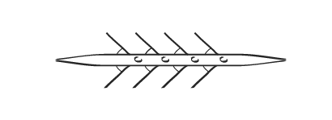 | Coxless Quad | 4x- | Four rowers with 2 blades each. One of the rowers steers with their foot – a cable runs from the foot plate to the rudder.
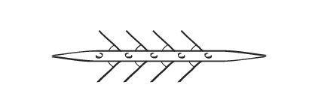 | Coxed Quad | 4x+ | Four rowers with 2 blades each and a cox to steer. This boat type is usually used by younger juniors and beginners.
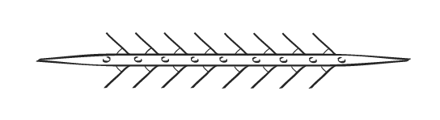 | Octuple | 8x+ | Eight rowers with 2 blades each and a cox to steer. This boat type is usually used by younger juniors and beginners.
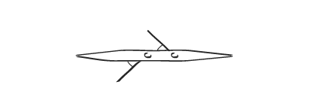 | Coxless Pair | 2- | Two rowers with one blade each; one on bow side the other on stroke side. One of the rowers steers with their foot – a cable runs from the foot plate to the rudder.
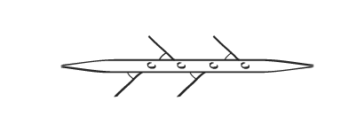 | Coxless Four | 4- | Four rowers with one blade each; two blades on each side of the boat. One of the rowers steers with the foot plate attached to the rudder (usually bow).
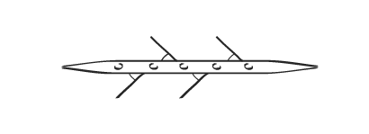 | Coxed Four | 4+ | Four rowers with one blade each; two blades on each side of the boat. A cox to steer the boat from either the bow or stern.
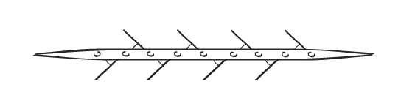 | Eight | 8+ | Eight rowers with one blade each; four blades on each side of the boat and a cox to steer.
Events: There are two main types of competitive events in rowing:
- Heads are time trials over a distance of approximately 3-7 kilometres, depending on the event, which happen during the autumn and winter months.
- Regattas are side-by-side races which happen during the spring and summer months.
Each event produces a poster outlining the events on offer, length of the course and other valuable information.
Seat Fees: Every event charges a fee per rowing seat in each boat. These are paid by the club and charged to each rower through their seat fee account.
What is a Master?
Age categories are as follows.
A Age 27 to 35
B Age 36 to 42
C Age 43 to 49
D Age 50 to 54
E Age 55 to 59
F Age 60 to 64
G Age 65 to 69
H Age 70 to 74
I Age 75 and up

What is PRI (personal ranking index)?
Once you start racing rowers will get points for racing and beating crews. The higher up you finish in an event, and the more crews you beat, the more Ranking Points you’ll get. The competition organisers pass this information to British Rowing who updates members’ records.

Ranking Points are awarded for heads and regattas and for sweep and sculling, coxes are also awarded Ranking Points depending on how well their crew does.

For further information follow this link:
https://www.britishrowing.org/events/entering-competitons/points-status/

You can view your Personal Ranking Index by logging into your British Rowing online membership account.

Glossary of rowing terms
Do you know your stroke side from your bow side?
Can you tell a quad from an octuple? Can you find the rigger and rudder? A short list of terms is given below. For a full list see the British Rowing glossary.
https://www.britishrowing.org/knowledge/online-learning/techniques-and-training/glossary/
Backstops: Legs flat, with the blade drawn up to your chest, the spoon flat on the water. The normal position for starting when practising.
Bowside: on the rower’s left side – may be termed ‘green’
Stokeside: on the rower’s right side – may be termed ‘red’
Frontstops: Legs bent (shins vertical), arms straight in front, with the blade in the water, squared. Only used when practising a racing start or the real thing.
Number off: Used by cox (or steer person) to determine if crew ready to row. Number from bow in coxed boat ie ‘bow, 2, 3 etc) or from stroke in coxless boat ie. ‘stroke, 3,2’.
Easy: The blade at 90º to the boat, the spoon feathered (spoon facing upwards). When the command is given while rowing, the blades should be held off the water until the cox says 'drop'. This is the position for setting the boat.
Row on: Means take a normal stroke. Usually given to a specific oarsman, pair or side when manoeuvring the boat
Back down: Used to manoeuvre the boat. The blade is square in the water with the concave face toward the bow (blade reversed). The blade is slowly but firmly pushed away from the body, and the body drawn down the slide by the legs.
Hold the boat: Used when a quick stop or turn is required. The blade is squared in the water and held firmly to ‘check’ the boat's movement.
Catch: The point in the stroke when the spoon is dropped in the water. This must be done as a crew to aid balance.
Finish: The end of the stroke, when the spoon is extracted from the water by knocking the handle down smartly. This must be done as a crew to aid balance.
Recovery: The movement down the slide towards the stern while the blade is off the water.
Drive (or leg drive): The part of the stroke while the blade is in the water, powering the boat.
Square: The position of the spoon when in the water during the drive. The blade should be squared well before the catch, not as it is dropped in (this may also be termed ‘square early’.
Feather: The spoon parallel to the surface of the water. This cuts wind resistance and means that if the blade does touch the water during the recovery, it will skim the surface.
Pressure The amount of effort applied by the rower to the power phase of the stroke (usually light, ½, ¾, firm or full).
Gate: The metal bar, tightened by a screw that closes over the swivel to secure the oar.
Heel Restraints: Attached to the heels of the shoes and to the foot plate. Compulsory safety feature that helps the rower to release their feet from the shoe in the event of a capsize.
Riggers: Metal fixtures at the side of a boat that has a “gate” to hold the blades. These are removed for transportation.
Rigger Jigger: A 10/13mm spanner used to take off/put on the riggers for transport of boats to/from events – called rigging and derigging. Every rower needs one of these at all times!
For information on the rowing stroke see link below:
https://www.britishrowing.org/knowledge/online-learning/techniques-and-training/water-rowing-technique/
The ergo a useful training tool. Information on technique is available here:
https://www.britishrowing.org/knowledge/online-learning/techniques-and-training/indoor-rowing-technique/

Communication Methods
A variety of means can be used to communicate about training and events, but this is mainly by email and WhatsApp. Please ensure that you keep your email and contact details address up-to-date with your coach and on the membership ClubHub portal. Email is used widely by the club to disseminate circulars eg Monthly Newsletter, official communications, etc.
The Club’s web site, Facebook page and Twitter have news and information about the club and rowing. http://www.henleyrowingclub.co.uk/
https://www.facebook.com/Henley-Rowing-Club-11409913069/
https://twitter.com/HenleyRC

Membership of British rowing
Everyone is encouraged to become a member of British Rowing, for training or competing, which provides you with personal accident and liability insurance as well as receiving a copy of the Rowing & Regatta magazine and other updates from British Rowing. The different categories of membership are explained (see link below). ’Row’ Membership is compulsory for racing. Regatta entries cannot be made unless you have a valid membership, paid annually from the anniversary of first joining. You will receive a membership card from British Rowing which is the racing licence. . For further details on membership types, benefits and costs see:
https://www.britishrowing.org/join/
The racing licence should be brought to all events as photo ID is required to collect your proof of winning and to collect your winners medals!

Club Policies
All of the Club’s policies can be found on the website.
https://www.henleyrowingclub.co.uk/club-rules-and-policies/
It is a condition of membership of Henley Rowing Club that you confirm that you have read, understood and agreed to Club policies which are located on the website. Those applicable to adults are listed here (there are also specific junior policies). Always refer to the web site for current information as policies may be updated and new ones added from time to time.
- HRC Charity Constitution
- HRC Bye laws
- HRC Codes of Conduct
- HRC Welfare Policy
- Water Safety Code HRC
- Data Protection Statement
- Racking policy_Sept 2019

Medical, Health and Safety

Health and hygiene
Please ensure that your coache is aware of any medical issues eg. asthma, epilepsy.
Training is quite intense and it is important to get enough rest so the body can recover. It is not advisable to train when feeling down and generally unwell. A good guide is to establish a resting heart rate first thing every morning before getting up. If the heart rate at any time is 10 beats or more above the norm then the coach needs to be advised to enable a decision to be made on training in conjunction with the rower and parent/carer.
There are additional hygiene considerations to be aware of near water, cleanliness is essential to minimise the risk of infection:
- Cuts and abrasions (including blisters) should be covered with waterproof dressings.
- Wear footwear to avoid cuts and protect feet.
- Wash blade handles after each outing.
- Shower after contact with the water.
- Wash hands thoroughly before eating and drinking. It’s a good idea to carry antiseptic hand gel in the kit bag.
The club has antiseptic hand gel dispensers in the gyms. Always wipe down equipment after use with the disinfectant sprays provided. Wash hands after training in the gym as well as after water sessions.
If applicable, please see the British Rowing statement on epilepsy:
https://www.britishrowing.org/knowledge/safety/health-and-fitness/rowing-and-epilepsy/
The following guidance on avoiding seasonal illness is helpful:
https://www.britishrowing.org/2013/01/avoiding-seasonal-illness/

Medication and drugs
The Club strongly believes in clean sport and follows British Rowing guidance on Anti-Doping. British rowing works in partnership with UK Anti-Doping (UKAD) and World Rowing, to protect the integrity of our sport.
Information on anti-doping from British Rowing can be found here: https://www.britishrowing.org/about-us/governance/anti-doping/
Medication that rowers are prescribed or buy over the counter can be checked for compliance with Anti-Doping rules at The Global Drug Reference Online (Global DRO) which provides information about the prohibited status of specific medications based on the current World Anti-Doping Agency (WADA) Prohibited List. https://globaldro.com/Home
Rowers should not use protein supplements or any other performance supplements, including gels.

Diet and hydration
Nutrition and hydration are important elements of all exercise. There is some basic information on nutrition on the British Rowing website and the Rowing and Regatta Magazine includes articles most months.
A healthy and balanced diet is important. This means three meals a day plus appropriate snacks, each day’s intake should contain a variety of food groups.
Hydration is also important; daily fluid intake should be around 2-3 litres in the winter and more in the summer and leading up to events.
Water bottles should not be shared by athletes as this could spread infection. Always bring your own bottle for training on the water and in the gym. Sterilise bottles regularly with Milton or similar.
Sports Drinks
Isotonic drinks (sports drinks) are absorbed into the body faster than plain water. They normally contain 4-8g sugar to rehydrate and refuel and salt to enhance the absorption of fluid.
Easy and cheap to make your own – mix together:
- 1 litre water
- 1.25g (1/4 teaspoon) salt
- 250ml squash or high juice squash (not sugar free or low calorie); or 100ml Ribena
Food at Events
Refueling and rehydration are important. Everybody likes different food, but here’s some key rules to apply:
- Start the day with a good breakfast such as porridge, Weetabix, toast/eggs.
- Avoid sugar highs and lows by eating food that provides a slow release of glucose, such as whole-wheat toast, cereals, pasta, fruit and vegetables.
- Snack on bananas, dried fruit, cereal bars etc. rather than chocolate and sweets.
- Replenish as soon after racing as possible, ideally within 20 minutes. Suggestions include squash (not sugar free)/home-made sports drink, milk, Yazoo or Alpro milkshakes, jam sandwiches, brioche, banana bread, honey bagels, Soreen malt loaf, Skyr yogurt pouches, yogurt and banana.
Everything in moderation but avoid sugary foods and drinks on race days!

Sun Exposure
Rowers and coaches are exposed to a higher intensity of sun than other athletes who do not train on the water. Reflection of the sun’s rays off the water results in increased exposure to harmful solar radiation. Use of sunscreen, hats and sunglasses are essential.
Always check the weather forecast then prepare and pack carefully for training or the day of an event.

Hypothermia
Hypothermia occurs when the body has been chilled to a much lower than normal temperature and can no longer maintain its heat. ie. below 35° C. Avoidance must be the first consideration at all times. It is important to dress to beat the cold – layers of clothing are more effective than one warm garment. The outer layer should be wind and waterproof. Remember the head is a source of large heat loss so it is important to wear a hat in cold weather. Be alert to the warning signs of cold both in yourself and others. Exposed arms and legs heighten the risk (see information on kit).
Always check the weather forecast then prepare and pack carefully for training or the day of an event.

Blisters
Blisters are an inevitable result of rowing but it’s important to prevent infection. Keep them covered to prevent infection. Here’s a link to an article about 6 ways to treat blisters:
https://www.rowperfect.co.uk/6-ways-treat-rowing-blister/

Weill's Disease – Leptospirosis and Bird Flu
Weil’s Disease, also known as Leptospirosis, is rare in Britain with around 40 - 50 cases reported each year; however the disease does kill one or two people every year. It is carried by water organisms, so those taking part in water sports can be at risk. In the early stages Leptospirosis can be mistaken for flu but can develop into jaundice, kidney and liver failure.
While the risk of contracting the disease from recreational water is very small, British Rowing is taking a precautionary approach and reiterating its advice that the serious nature of the disease means that rowers must be aware of the dangers and should take simple, routine precautions to reduce the risk of infection.
The most likely place for Leptospirosis to be found is in stagnant water, water that is adjacent to farm land and any water where rodents are common. Further information related to safety aspects on water borne diseases can be found at:
https://www.britishrowing.org/2012/01/advice-for-the-prevention-of-weils-disease/
If flu-like symptoms develop shortly after contact with the water contact your doctor and advise that you are a rower. Please let your coach know.
There are sometimes lots of geese leaving a mess at the club! General hygiene as discussed above is advised.

First aid equipment and defibrilator
First aid kits are located in the upstairs gym, boat house and down stairs gym. A defibrillator is located in the downstairs gym. A list of first aiders is included on the safety notice board in the club house.

Pontoons (rafts)
Only step on to the pontoons when required to boat. If you are not rowing only step on to the pontoon when asked to do so by your coach or if needed to help a boat come in. Visitors, and especially small children, should not step on to the pontoons.
Take care when boating from the pontoons to step over the gaps and when stepping up on to the bank.
Trainers/shoes should be worn properly when carrying boats to avoid the risk of tripping and accidents or damage to rowers and equipment.
Blades should not be placed on the pontoons at any time but placed on the concrete or grass near the pontoons. When placing blades on the ground before and after an outing make sure that the handles do not hang over the edge as this causes a trip hazard.

What to wear: Rowing kit

Competition kit
The most important piece of racing kit is the all-in-one (AIO) in the Henley Club colours. Every crew must wear identical clothing in club colours for racing. In winter a tee-shirt (long or short sleeve) is worn under the all-in-one; all crew members must wear the same colour – usually white.
Kit is purchased from Crewroom (JL brand) or Termaxx via “purchasing windows” in September & April. Members will receive an email giving notice when the ordering system is open. This allows for a bulk order with lead times of 4-6 weeks for race kit, 6-8 weeks for outerwear. Kit is delivered to the club then distributed to members.
Whilst members may purchase as much or as little of the kit as they want, we suggest that they own at least a Henley all-in-one, leggings and a short/long sleeved technical top for inclement weather. A gilet or splash top is preferable for waiting on cold start lines and training throughout the winter.
For enquiries about racing kit please contact: kit@henleyrowingclub.org

Training kit
Rowers need to bring a bag of kit and be prepared for anything the elements may throw at them! Training kit can be any make, it does not need to have a HRC logo nor be the competition kit.
Basic requirements:
- Leggings and top-layers are important depending on the weather
- Wind and waterproof outer layer
- Shorts/all-in-one for land training or rowing in the summer. Shorts are not sufficient in cold weather
- Hat – for warmth in the winter and sun protection in the summer
- Sun glasses - even an early morning outing can be sunny
- Poggies (special rowing mittens available online from various sources) can be used to keep hands warm when rowing in the winter; ordinary gloves are not suitable for rowing
- Rigger Jigger
- Small dry water proof bag for kit in the boat as layers are removed/put on during a training session
- A complete change of kit is essential
- Extra dry kit and a towel should be brought to the club at all times in case of capsize and/or adverse weather conditions, especially when more than one training outing can be expected.
- A plastic bag is useful to hold wet kit
- Sun cream
- Hand gel
- Small first aid kit: plasters, blister tape, paracetamol
Training kit with the HRC logo is available via the website. Look for the ‘HRC shop’ link. Any profit goes directly back in to club funds and benefits its members. If you have any questions contact kit@henleyrowingclub.org.

We strongly recommend that all kit is named as it does tend to be left about and can be thrown away or used as a cleaning rag if not claimed! Un-named/un-claimed kit is put in a lost property bin in the gym. These should be checked regularly as unclaimed kit maybe disposed of.
Suitable footwear should be worn at all times –bare feet or socks are not allowed for safety reasons.
Sometimes it is not possible to row due to the river conditions so land training is undertaken. This can involve a run, so it is important that suitable trainers are worn. Muddy trainers should not be worn in the gym or for ergo sessions.
Please also refer to information on clothing provided earlier (Hypothermia).

Events – Regattas and Head Races

Dates
The squad coaches will have a general idea of what competition events are suitable and which they wish to enter. These will be communicated to the squads via the usual communication channels.
A useful link for the regatta racing calendar is here:
http://www.biddulph.org.uk/rowing.htm#calendars

Help at Events
Towing: The club needs volunteers to tow boat-loaded trailers to events. If you have a tow bar on your vehicle, a driving licence with B+E category and are willing to tow, please get in touch with the Captain or one of the Vice Captains.
Boat loading: Boats are normally loaded on a Thursday evening before an event. The coach will advise when this will be happening. A loading plan will be given. Boats must be tied down correctly and training will be given. Always ask for help if not sure. Blades must also be loaded on to the trailer tidily.
Rigging: The crew is responsible for de-rigging the boat for loading and rigging for the event. After the end of the event the boat is de-rigged and loaded. Ensure that it is tied on securely – if not sure ask. Guidance will be given. The crew should arrange for the boat to be re-rigged and returned to the rack when back at the club. Boats should not be left on the trailers.

Costs - Competition, Travel and Accommodation
Apart from Club membership and British Rowing membership fees there are additional costs as follows:
Seat fees – racing fees:
Seat fees are typically in the region of £10 - £15 per event. For example, if you compete in a 2x and a 4x there will be two fees to pay for the event. Fees are payable even if the event is scratched by the coach due to clash of timetables or if someone is not available to race and a substitute cannot be found.

Trailer Towing Costs
Trailering costs vary depending on the event and the distance from Henley. To make this as simple and fair as possible trailering costs are charged based on 3 zones and the charge will be made per seat. i.e. those who race more than once will pay more than one trailering fee for that event.
Zone A, £1.75* - Dorney, Marlow, Reading, Wallingford, Maidenhead
Zone B, £3.50* - London, Hampton, Bedford, Weybridge, etc
Zone C, £6.00* - Nottingham
* subject to review annually
Trips to Europe and north of Nottingham will be calculated individually.
Host Clubs There can also be an additional cost when racing on the Tideway in London to the host club, depending where crews boat from. This includes pairs head, scullers head, fours head and eights heads. These costs are typically £5-£10 per person. Coxes do not pay seat not trailering fees.

Useful Location Information
Dorney
Dorney Lake is used for a number of events which we attend and sometimes for training when we are not able to row at Henley due to the river conditions.
How to get there? Address: Dorney Lake, Eton College Rowing Centre, off Court Lane, Dorney, Windsor, Berkshire, SL4 6QP
https://dorneylake.co.uk/
There is usually a parking charge for spectators. There is a large Sainsbury’s supermarket about 5 minutes from the Lake, on Lake End, the road from the A4 to the Lake. Dorney has a café which is usually open and for large events there are mobile caterers.
Nottingham
The National Water Sports Centre is at Adbolton Lane, Holme Pierrepont, Nottingham NG12 2LU
http://www.nwscnotts.com/
There is normally a daily carparking charge for spectators at the events.
There is a large Morrison’s supermarket about 3km from the centre. The NWC has a café and there are mobile caterers around for the events.

Photographs
We like to promote wins and celebrate success through the Henley Standard and other local papers, on our website and in any promotional materials we may produce to attract potential sponsors.
When taking photos of winning crews please ensure that all kit is correctly worn (ie all-in-one’s pulled up) and matches (ie all wear the same as far as possible and make sure the cox is also wearing a Henley top). Sun glasses should not be worn for photographs. It is helpful to email crew photographs to the coach/ co-ordinator. These can then be forwarded to our press officer together with a report (often written by the coaches) for the newspaper (deadline is Monday for a Friday publish). Wins and regatta reports are collated by the club and appear on the Clubs’ website.

Boats and equipment
All squad boats and equipment are provided by the Club. Each squad has a specific colour code (for blades and boats). This is a coloured ‘dot’ on the boat and same colour tape on the blades. Blades are racked by squad and should be replaced in the same rack. Boats are returned to the same rack and must be tied down securely.
Squad colours are:
- Masters – yellow
- Senior Women – purple
- Senior Men – white
- Junior Women 15 – 18 years – yellow/green stripe
- Junior Men 15 – 18 years – blue
- Junior Women 14 years – yellow/red/black
- Junior Men 14 years - silver
- Juniors 13 years – red
If you do own a boat, then this will need to be racked at the club. Racking fees are paid to the club. There is a waiting list for racks. Please contact racking@henleyrowingclub.org if you wish to apply for a racking space.
Boat insurance will also be necessary which can be arranged through the club or independently.
You may wish to think about having your own single sculling boat, but this is not compulsory. Second hand boats are sometimes available at the club or can be seen for sale on various web sites. If you need any help, please contact a coach or the Captain for advice on a suitable boat.
All boats will be issued a three letter (HEN) code together with a three-digit fleet number. Boats not correctly displaying the code will not be eligible to race.
Sculling blades may be purchased to use with own boats, but club blades can be used. Please name blades. There is an area at the club for personal blade storage.

Boat House and care of equipment
Pay attention at all times when moving boats and equipment. Don’t rush and take care placing boats on the water and when returning to racks.
All boats should be wiped down after use. Old towels are provided and these should be hung up after use. There is a washing machine available to wash towels.
Don’t leave blade handles hanging over the side of the concrete – they are a trip hazard when moving away from or to the rafts. Return blades after use into the correct place. Wipe down handles if dirty.
Loading the trailers to transport boats and equipment to events must be done correctly to prevent damage to equipment. The coaches will instruct on how this should be done.
Equipment failures must be noted to the coach or Captain. The Masters Group has a boat repair log within an online masters portal (a link will be provided on joining the masters squad).
Please keep the club tidy by not leaving unwanted bottles lying around as they get thrown in landfill or end up polluting the river. Try to think about re-use and recycling bottles. Water bottles should be sterilized regularly.
Keep the changing rooms tidy and don’t leave kit or shoes lying around. Lost kit is put in specific bins at the club house which are emptied frequently, about every two months. Please check regularly if you have lost an item.
The boat house doors, gym door and clubhouse door should be locked when the last person has come in and boats are away. Lights should be switched off!

Risk assessment and Rules of the river
All members must follow the local water safety code and undertake a risk assessment before boating. This is available on the Safety Notice Board and on the club web site. Training on rules of the river is an important part of the Learn to Row course and is reinforced by coaches as necessary. Always seek advice from an experienced member or coach if not sure. Remember: if in doubt, don’t go out.
All coaches and rowers have a responsibility to follow the British Rowing Water Safety Code and Water Safety Code for the Club. Further information is at:
http://www.britishrowing.org/taking-part/staying-safe/rowsafe
The club’s Safety Officer can be contacted via safety@henleyrowingclub.org
For reference, a copy of the navigation plan for the Henley Reach is provided in this document. Further information is available from the club’s Safety Officer. Please also refer to the Safety Notice Board in the clubhouse.

Appendix 1: Navigation plan for the Henley Reach
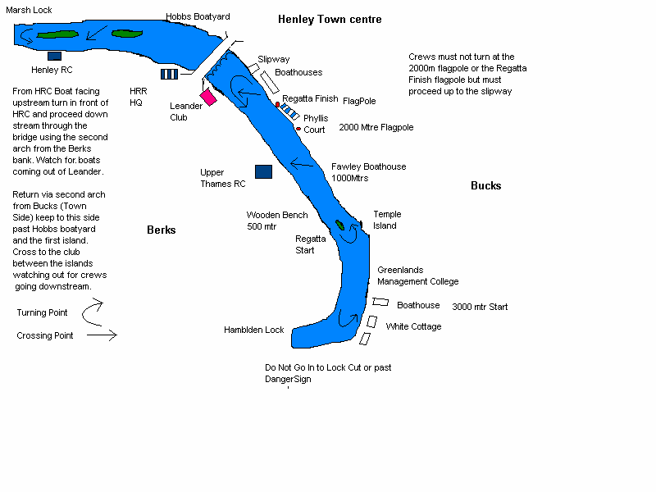
The rule is keep to the right; that is crews (and scullers) proceeding downstream from Henley Bridge to Hambleden Lock keep to the Berks (Clubs) side, and those coming upstream from Hambleden Lock toward the Bridge keep to the Bucks (Town) side. Temple Island is always passed to the right (ie. the island on stroke side).
Crews being overtaken have a duty to stay clear but must take care not to stray into the centre of the river particularly when coming upstream.
Crews should always boat facing upstream and have a duty to avoid those coming downstream.
Particular care must be taken when crossing to and from the Bucks (Town) side to gain access to or leaving club landing stages, and crews coming downstream have right of way at all times.

